**Evaluation Metrics**

### **1. DocVQA Accuracy**

**Definition**:  
DocVQA Accuracy measures the model’s ability to correctly answer questions based on document images (e.g., scanned forms, invoices, contracts). It tests both visual layout understanding and natural language comprehension.

**Formula**:

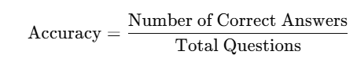

**Where**:

* *Correct Answers*: Model predictions exactly matching ground truth answers
* *Total Questions*: Total visual questions asked on documents

**Examples**:

1. Given an invoice image, Q: “What is the total due?” → Model answers “₹1,500.00” → Correct
2. Document: Certificate. Q: “What is the date of issue?” → Model replies “15 August 2022” (exact match) → Correct

**Applications**:

* Visual question answering over documents
* OCR(optical character recognition) -based form understanding
* Intelligent document processing (IDP)

### **2. Information Extraction F1**

**Definition**:  
Measures how accurately a model extracts structured information (entities, slots) from unstructured text. Combines precision (correctly predicted items) and recall (all actual items retrieved).

**Formula**:

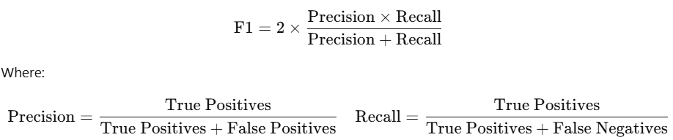

**Examples**:

1. Text: “Elon Musk founded SpaceX in 2002 in California.”  
    Extracted: {ORG: SpaceX, PER: Elon Musk, DATE: 2002} → High F1
2. Text: “Google was established by Larry Page and Sergey Brin.”  
    Misses one founder or adds wrong info → F1 drops

**Applications**:

* Named Entity Recognition (NER)
* Resume parsing, clinical report extraction
* Knowledge base population

### **3. Natural Questions F1**

**Definition**:  
Used in open-domain QA, it evaluates token-level overlap between the predicted answer and the ground truth. Useful when answers are not exact matches but partially correct.

**Formula**:  
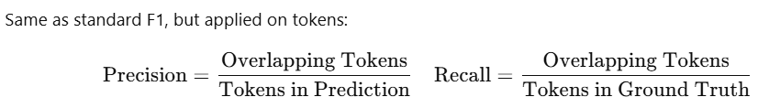

**Examples**:

1. GT: “Barack Hussein Obama”, Prediction: “Barack Obama” → Partial token overlap → F1 ≈ 0.66
2. GT: “United States of America”, Prediction: “USA” → No token overlap → F1 = 0

**Applications**:

* Open-domain QA systems
* Knowledge-grounded assistants
* Chatbot evaluation

### **4. Exact Match (EM)**

**Definition**:  
Binary metric: determines whether the model’s output exactly matches the reference answer. Highly strict, no room for partial correctness.

**Formula**:

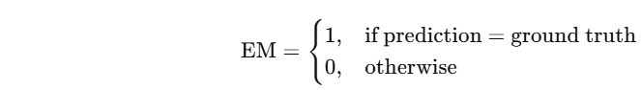

**Examples**:

1. GT: “Marie Curie”, Prediction: “Marie Curie” → EM = 1
2. GT: “Saturn”, Prediction: “planet Saturn” → EM = 0 (extra word)

**Applications**:

* Reading comprehension
* Short answer evaluation
* QA datasets like SQuAD

### **5. Relevance**

**Definition**:  
Assesses whether the retrieved/given content is topically relevant to a user's query. Usually evaluated using scoring models or human judgments.

**Formula**:  
No fixed formula — may use:

* Cosine similarity
* BERT-based scoring
* Human annotations (Likert scale)

**Examples**:

1. Query: “Photosynthesis steps” → Retrieved: “Plants use chlorophyll to convert sunlight…” → Relevant
2. Query: “India’s GDP” → Retrieved: “Population growth in Africa” → Irrelevant

**Applications**:

* RAG pipelines
* Document retrieval
* Context selection in QA

### **6. Faithfulness**

**Definition**:  
Evaluates factual correctness of generated outputs relative to the source context. Penalizes hallucinations or contradictions.

**Formula**:  
No standard formula; typically evaluated using:

* Fact-checking models
* QA over references
* Human judgment

**Examples**:

1. Input: “Obama was president in 2009.” Output: “Barack Obama served as president starting in 2009.” → Faithful
2. Input: Same. Output: “Donald Trump began his term in 2009.” → Unfaithful

**Applications**:

* Factual summarization
* RAG-based generation
* Scientific/medical text generation

### **7. Context Recall**

**Definition**:  
Measures how many of the relevant context documents (ground truth) were successfully retrieved by the model.

**Formula**:



**Examples**:

1. Ground truth: 5 documents. Retrieved: 4 correct → Recall = 0.8
2. Ground truth: 3. Retrieved: only 1 → Recall = 0.33

**Applications**:

* Retrieval-Augmented Generation
* Multi-hop QA
* Knowledge retrievers (e.g., DPR, BM25)

### **8. Dialogue Coherence**

**Definition**:  
Checks whether a chatbot's responses follow logical, topical, and contextual consistency with the conversation history.

**Formula**:  
No fixed formula; evaluated using:

* Coherence models
* Human rating scales (1–5)
* Discourse modeling

**Examples**:  
 1. User: “What’s the weather like?”  
 Bot: “It’s sunny and warm today.” → Coherent  
 2. User: “Tell me a joke.”  
 Bot: “India's independence was in 1947.” → Incoherent

**Applications**:

* Conversational agents
* Customer service bots
* Virtual assistants

### **9. Intent Match**

**Definition**:  
Checks whether the model correctly identifies and acts on the user's intended goal. Important for task-oriented systems.

**Formula**:

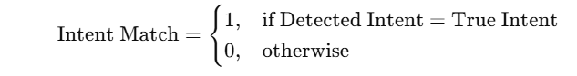

**Examples**:  
 1. User: “Remind me to drink water.” → Detected: Reminder → Match = 1  
 2. User: “Book me a table.” → Detected: Weather Inquiry → Match = 0

**Applications**:

* Virtual assistants
* Command and control systems
* Voice bots (Alexa, Siri)

### **10. GPTScore**

**Definition**:  
Uses a GPT model to evaluate generated text by assigning scalar scores or pairwise rankings based on fluency, coherence, and informativeness.

**Formula**:  
No universal formula. Can involve:

* Prompted scoring
* Log-likelihoods
* Pairwise preferences

**Examples**:

1. Prompt GPT-4: “Rate this response on coherence (1–5)” → Output: 4 → Score = 4
2. Given two summaries, ask GPT: “Which is better?” → Uses preference to score

**Applications**:

* Model evaluation without humans
* Preference-based RL training (RLHF)
* Summary and generation grading

### **11. Rubric Evaluation Accuracy**

**Definition**:  
Measures how well the model output satisfies pre-defined criteria (e.g., grammar, content, structure), often used in structured assessments.

**Formula**:

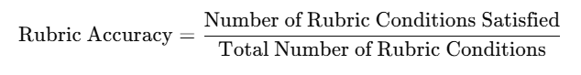

**Examples**:

1. Rubric: Grammar, Structure, Relevance, Detail  
    Output satisfies 3/4 → Accuracy = 0.75
2. Essay meets only 1 criterion → Accuracy = 0.25

**Applications**:

* Essay grading
* Formal answer evaluation
* Generative model benchmarking

### **12. ROUGE-L**

**Definition**:  
Evaluates summary quality using the longest common subsequence (LCS) between reference and generated text, capturing fluency and phrase-level similarity.

**Formula**:

* LCS = Longest Common Subsequence
* Precision = LCS / Gen Length
* Recall = LCS / Ref Length
* F1 = Harmonic Mean of Precision and Recall

**Examples**:  
 1. Reference: “The dog barked at night.”  
 Generated: “The dog barked loudly.” → Partial LCS → Medium ROUGE-L  
 2. Reference: “India won the match.”  
 Generated: “India won the match.” → ROUGE-L = 1

**Applications**:

* Text summarization
* Headline generation
* Story simplification

### **13. BERTScore**

**Definition**:  
Calculates semantic similarity between reference and prediction using contextualized BERT embeddings, capturing meaning beyond exact words.

**Formula**:



**Examples**:  
 1. Ref: “Dogs are friendly.”  
 Gen: “Canines are kind.” → High semantic similarity → High BERTScore  
 2. Ref: “Paris is the capital of France.”  
 Gen: “Eiffel Tower is in Europe.” → Low semantic overlap → Low score

**Applications**:

* Paraphrase detection
* Machine translation
* Semantic summarization

### **14. BLEU (Bilingual Evaluation Understudy)**

**Definition**:  
BLEU measures the overlap of n-grams between a machine-generated sentence and one or more reference sentences. It focuses on precision — how many of the generated words are also in the reference — and is used widely in machine translation.

**Formula**:

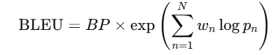

Where:

* BP: Brevity Penalty to penalize short outputs
* pn: Modified n-gram precision for n=1 to N (usually N=4)
* wn: Weight for each n-gram level (typically uniform)

**Examples**:  
 1. Ref: "The cat is on the mat"  
 Gen: "The cat is on mat" → 4-gram match partially missed → Lower BLEU  
 2. Ref: "He is playing football."  
 Gen: "He is playing football." → Perfect match → BLEU = 1.0

**Applications**:

* Machine Translation (MT)
* Text generation tasks
* Summarization (less common due to precision bias)

### **15. COMET (Crosslingual Optimized Metric for Evaluation of Translation)**

**Definition**:  
COMET is a neural metric that evaluates translation quality using a pretrained multilingual encoder. It considers both source and reference sentences to estimate adequacy and fluency.

**Formula**:  
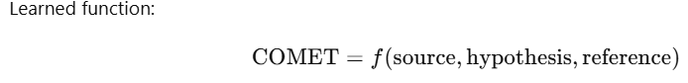

Where f is a neural regression model predicting human judgment scores.

**Examples**:  
 1. Source (en): “I love my dog.”  
 Hypothesis: “J’adore mon chien.”  
 Reference: “J’aime mon chien.” → Semantic match → High COMET score  
 2. Source: “It is raining.”  
 Hypothesis: “Le soleil brille.” (Sun is shining) → Incorrect → Low COMET

**Applications**:

* Machine Translation evaluation
* Cross-lingual summarization
* Reference-free MT scoring (with COMET-QE)

### **16. chrF++ (Character n-gram F-score)**

**Definition**:  
chrF++ evaluates text generation quality based on character-level n-gram overlap (plus some word-level matching), making it robust to morphology and minor word order variations.

**Formula**:

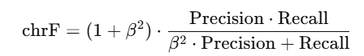

* Precision & Recall are computed over character n-grams
* Typically β=2 to favor recall

**Examples**:  
 1. Ref: "unbelievable"  
 Gen: "unbeleivable" → Small typo → High chrF  
 2. Ref: "The weather is good."  
 Gen: "Climate is nice." → Different wording → Low chrF++

**Applications**:

* Machine translation for morphologically rich languages
* Text simplification
* Spelling-robust scoring

### **17. Factuality Score**

**Definition**:  
Factuality Score evaluates how factually accurate the generated text is with respect to known or verifiable information. Often derived from QA-based methods or fact-checking classifiers.

**Formula**:  
No fixed formula; based on:

* Fact-checking model outputs
* QA over source documents
* Human annotations (True/False labels)

**Examples**:  
 1. Source: “The capital of France is Paris.”  
 Output: “France's capital is Paris.” → Factual  
 Output: “France’s capital is Lyon.” → Not factual → Low score

**Applications**:

* Scientific or medical summarization
* News generation
* RAG system outputs

### **18. Faithfulness Score (Reused)**

**Definition**:  
Sometimes reused or calculated differently across tasks, this version focuses on checking whether model generations remain grounded in the input context — especially in summarization or generation from evidence.

**Formula**:

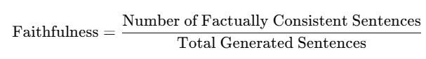

**Examples**:  
 1. Input: Wikipedia article on Einstein.  
 Summary: “Einstein developed relativity.” → Faithful  
 Summary: “Einstein won a Grammy.” → Hallucinated → Not faithful

**Applications**:

* Abstractive summarization
* Dialogue generation
* LLM hallucination detection

### **19. Creativity Score**

**Definition**:  
Measures the novelty or inventiveness of the model’s output. Often scored manually or by prompting GPT models to rate novelty, uniqueness, and surprise value.

**Formula**:  
No standard formula; usually:

* Human rating (Likert scale)
* Model-based scoring (e.g., GPT: “Rate the creativity from 1–5”)

**Examples**:  
 1. Prompt: “Write a story about a clock that eats time.” → Creative response = High score  
 2. Prompt: “Tell a joke.”  
 Model says: “Why did the chicken cross the road?” → Overused → Low score

**Applications**:

* Story generation
* Ad copywriting
* Creative writing tools

### **20. Story Coherence**

**Definition**:  
Evaluates the logical flow and consistency of narrative elements in a generated story. Focuses on character consistency, event ordering, and cause-effect chains.

**Formula**:  
No formal formula; judged by:

* Coherence classifiers
* Human judgment (e.g., consistency score out of 5)

**Examples**:  
 1. Story: “She woke up, then ate breakfast, and left for work.” → Logically coherent  
 2. Story: “He died in chapter 2 but fought dragons in chapter 4.” → Incoherent timeline

**Applications**:

* Story generation (e.g., novel writing AI)
* Game narrative generation
* Script and scene modeling

### **21. Recall@K**

**Definition**:  
Measures whether at least one of the correct answers appears in the top-K results retrieved by a model. Common in retrieval and ranking tasks.

**Formula**:

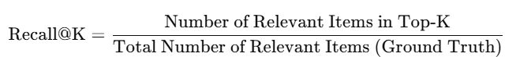

**Examples**:  
 1. Query: “Who discovered penicillin?”  
 Top-5 results include “Alexander Fleming” → Recall@5 = 1  
 2. Top-5 results: “Newton, Darwin, Pasteur…” → Missed correct answer → Recall@5 = 0

**Applications**:

* Document ranking
* RAG retrievers
* Multi-hop QA

### **22. Precision@K**

**Definition**:  
Measures how many of the top-K retrieved items are relevant. Unlike Recall@K, it penalizes irrelevant results.

**Formula**:



**Examples**:  
 1. Top-5 docs: 3 are relevant → Precision@5 = 3/5 = 0.6  
 2. Top-10 docs: only 2 are relevant → Precision@10 = 0.2

**Applications**:

* Search engines
* QA retrieval systems
* Evaluation of document retrievers

### **23. Mean Reciprocal Rank (MRR)**

**Definition**:  
Evaluates how early in the ranked list the first relevant result appears. The reciprocal rank of the first correct answer is averaged over multiple queries.

**Formula**:

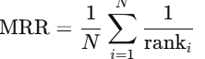



**Examples**:  
 1. Correct doc at rank 1 → Reciprocal = 1  
 2. Correct doc at rank 5 → Reciprocal = 1/5 = 0.2

**Applications**:

* QA and search
* RAG retriever evaluation
* Legal or academic document search